Step 1:
AI Transparency, I used Gemini to ensure that I understood how each of the forms of encryption works in how it handles encryption. I did not use it to answer any of the questions I was asked.
https://gemini.google.com/share/d234daa8e81b

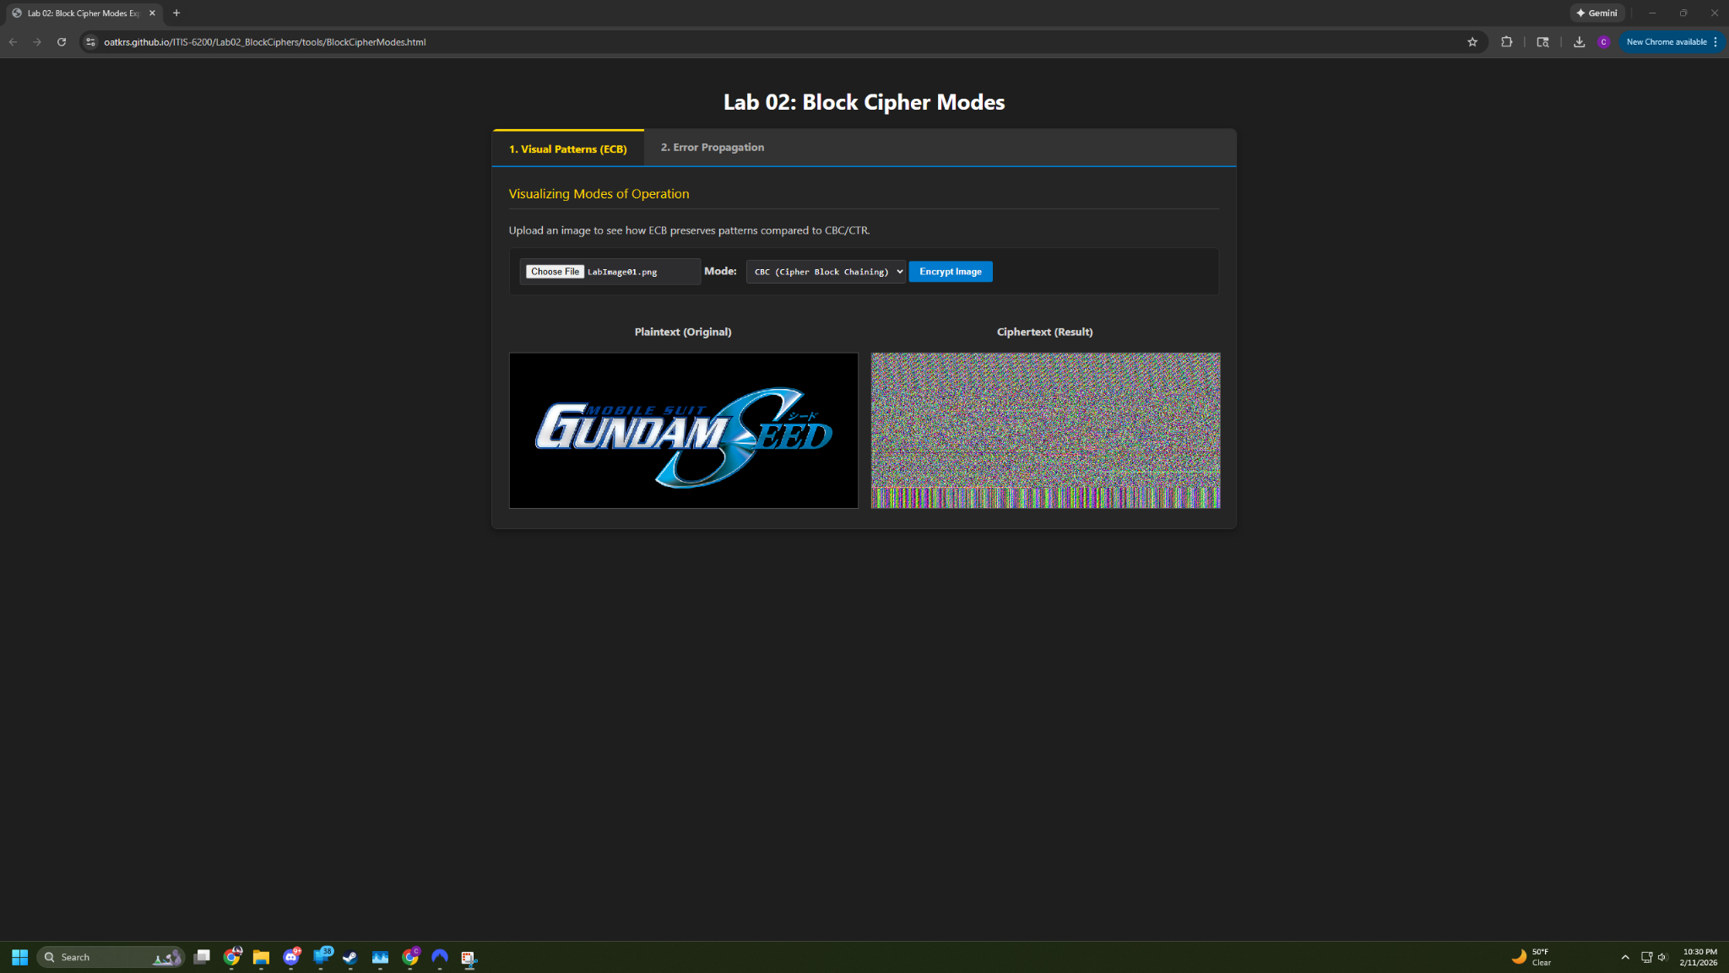

Q1: ECB preserved more of the visual patterns in the image because ECB preserves each block of data (or pixel in this case), individually from each other and uses the same encryption key for each. Because of that, any colors in the image are going to be encrypted to the same cipher color which preserves basically the entire image. This is actually what could cause the encrypted image to leak information about the original as well, exactly because pixels of the same color would end up with the same output.

Q2: With ECB encryption of the image, I basically got the exact same image out of it, the colors were just different. With CBC, most of the image was just pixel noise, but there were occasional patterns that could be noticed, especially near the top and bottom of the encrypted image. I’d guess this is because of how it’s chaining encryption? With CTR, the entire image is just visual and pixel noise. While CBC and CTR have some similarities in that they have visual noise, CBC has some patterns in it, though none of them are really decipherable, while CTR has no patterns whatsoever. Neither of them are remotely similar to ECB however. Looking at each of them, I would say that CTR provides much better encryption compared to ECB with CBC coming behind it in second. I’d say CTR is the best because it results in a completely random output, probably due to it using nonces and counters.

Q3: For ECB, it’s pretty obvious how resolution could affect the image. As you lower the resolution, it’d probably get more “secure” due to you no longer being able to cleanly make out what the original image was. That’s because we recognize images based on patterns and since ECB just encrypts everything individually, a lower resolution would mean that it would be more difficult for an attacker to recognize the original image as it’s resolution is lowered. For CBC and CTR, I’m not actually sure how a lower resolution would impact either of them. I’d imagine that, due to CBC’s use of chaining and CTR’s use of a nonce/counter, that resolution wouldn’t actually have any impact on an encrypted image and (while the results would be unique), the quality of its encryption would be the same as before.

Step 2:
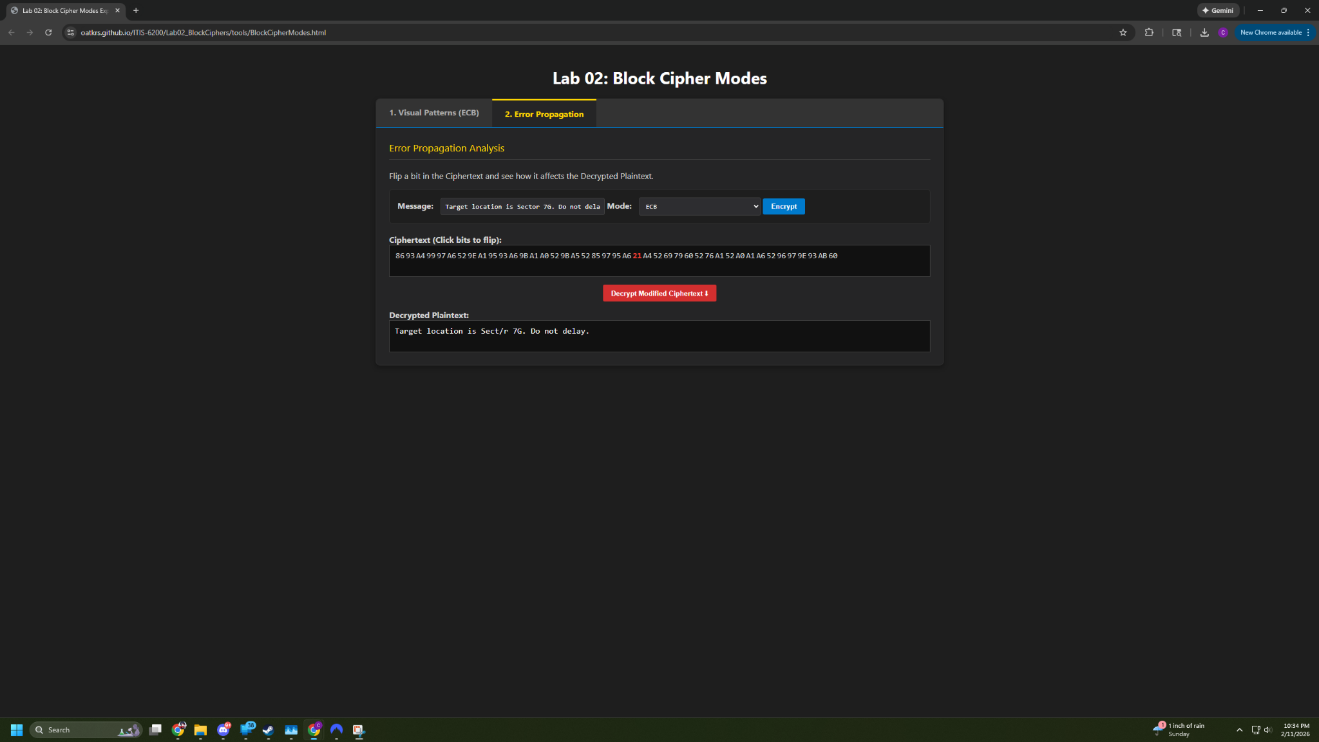
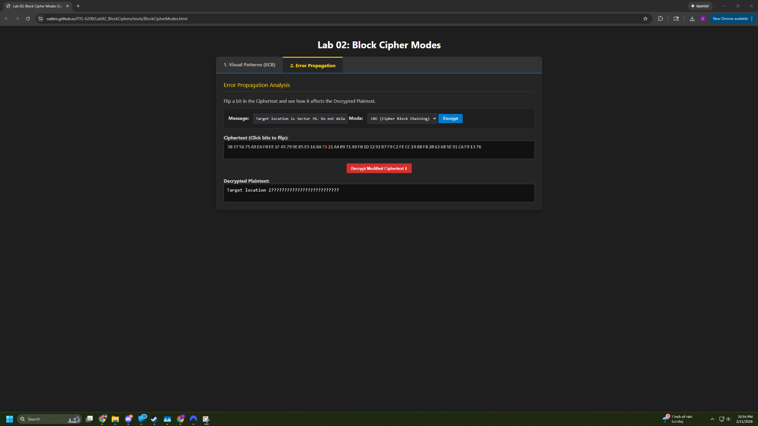
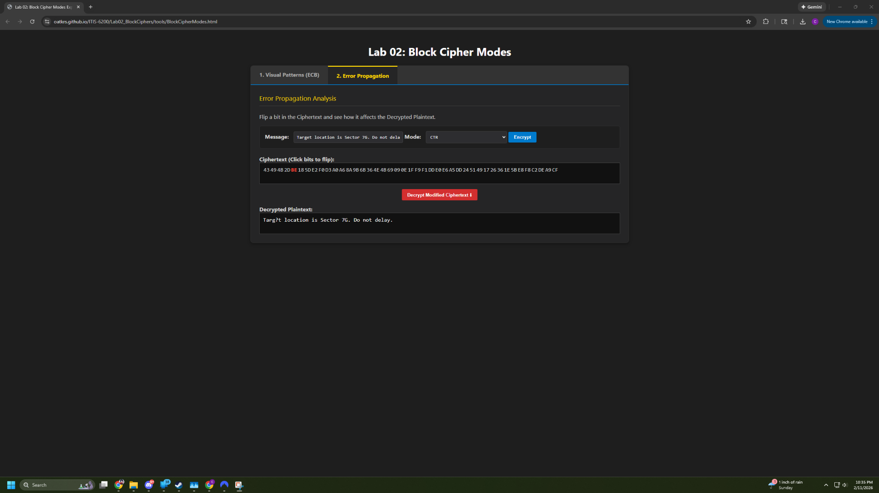

Q4: ECB having a bit flipped did very little to corrupt the decrypted ciphertext. It seems like the only part of the message that was corrupted was from the exact bit that I flipped and nothing else. Shows that ECB doesn’t have cascading encryption so that’s good to know. For CBC, it does seem like it has cascading encryption, which makes sense given it using chaining to encrypt. Everything from the bit flipped on was corrupted. CTR didn’t perform as well as CBC. It, like ECB, only had the flipped bit be corrupted. Makes sense given that each encrypted bit is done so through a nonce + counter so they don’t rely on previous bits for encryption.

Q5: For Alice’s goal, the only option is CBC. Since it uses chaining for its encryption and effectively has a cascading failure if a bit is flipped and the message is tampered with, this is really the only option for encryption out of these 3.

Q6: Since we’re streaming video, I would actually say that ECB would be the best option here. Since encryption with ECB concerning images isn’t pretty poor in the first place, having a bit be flipped in transmission isn’t likely to affect a user’s ability to determine what the decrypted image is. Rather, its only big impact would be to the color correctness and potentially quality of the image instead of actually corrupting portions of whatever they’re watching.

Step 3:
Q7: IV reuse affects CTR considerably more than CBC due to CBC’s use of chaining encryption. Since each data block (bit), relies on the one prior to it for encryption, reusing an IV on CBC doesn’t compromise the entire message as the encryption for each relies on the bit before it. I do think it could compromise the message if the original ciphertext’s were identical. I think they’d encrypt the same then. For CTR, since each bit is encrypted individually using a nonce and counter, reusing an IV would cause CTR’s keystream to be identical so it’d end up encrypting the two different plaintexts similarly.

Q8: I’d consider parallelized encryption to be more important in use cases where the speed of data being able to be used is important. Given that, I’d say that for something like a hard drive or especially an SSD, where the speed a user is able to access data directly affects response time and user experience, encryption like CTR would be used since each bit can be encrypted/decrypted simultaneously. Meanwhile, I’d think that CBC is used more for use cases where the speed of data being accessed isn’t all that important and security is instead. I’d think maybe something like a login key or some data connection that needs to be secure. Asking Gemini, it gave examples like legacy VPNs, SSL (which makes a lot of sense), and PDFs. https://gemini.google.com/share/73275f2f673e

Q9: This calculation compromises CTR because it can cause the keystreams used by CTR to be identical and thus can cause them to cancel each other out. You end up getting C1 XOR C2 to be identical to M1 XOR M2. Because of that, as long as you know part or all of M1 (or M2), you could reveal M2 (or M1). The same can’t be said about CBC because it doesn’t exactly use a XOR keystream. Since it uses chaining and the next bit encryption is based on the last bit encrypted, the equation changes a bit as you’d have to factor in the encryption function and that means that even if you reuse an IV, eventually, the ciphertexts will differ and means that compromising CBC with a reused IV isn’t likely. Gemini gave me a lot of help with this question. https://gemini.google.com/share/62f970a623a4

Step 4:
Github Link: https://github.com/Atom1cWinter/ITIS-3200/tree/Lab02





